**Introduction:** In this lab, we understood the concept of a more complicated signals by frequency modulation, and amplitude modulation.

Problem 3.4 in text

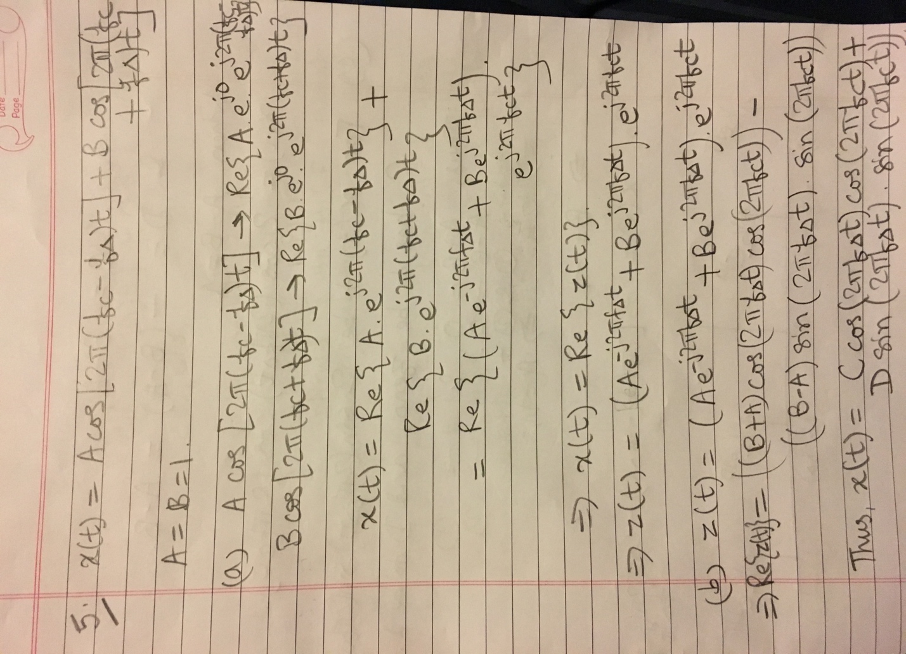

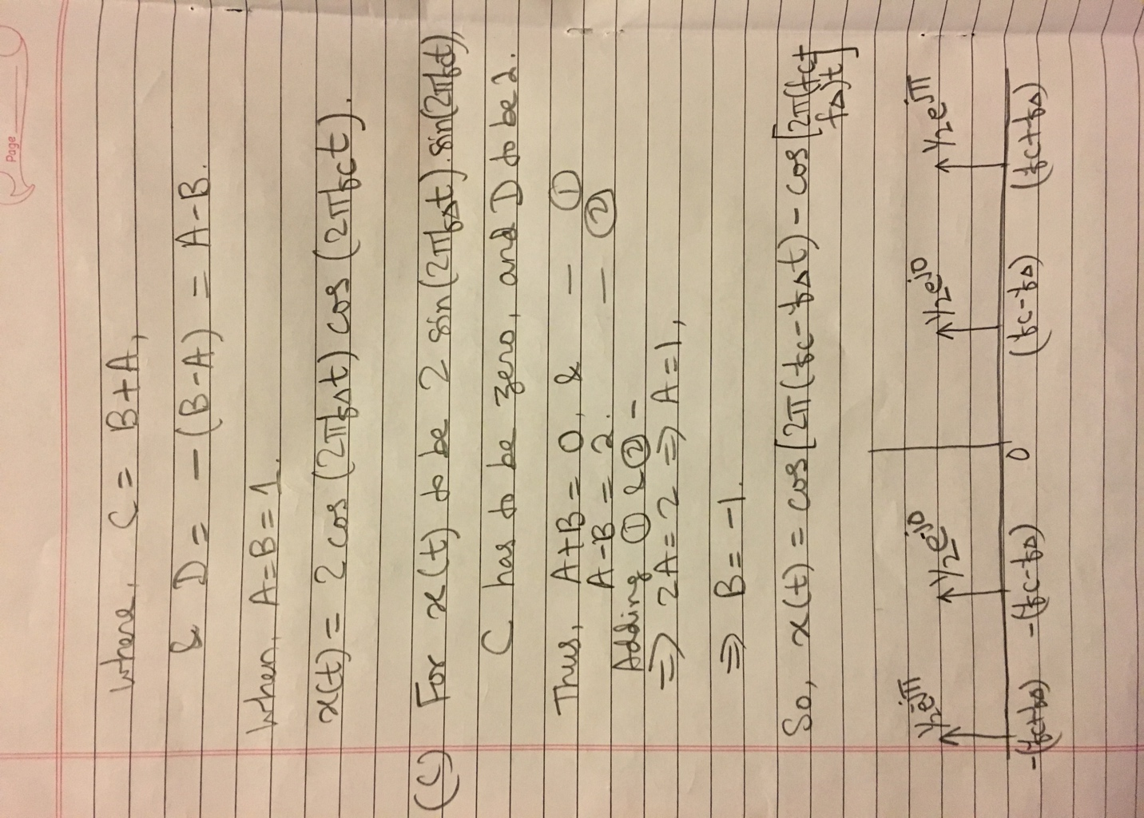

2.3 N = 1024;n = (0:N-1);

w0 = 2*pi/5;

x = sin(w0*n)+10*sin(2*w0*n);

spectrogram(x,128,64,[],100);

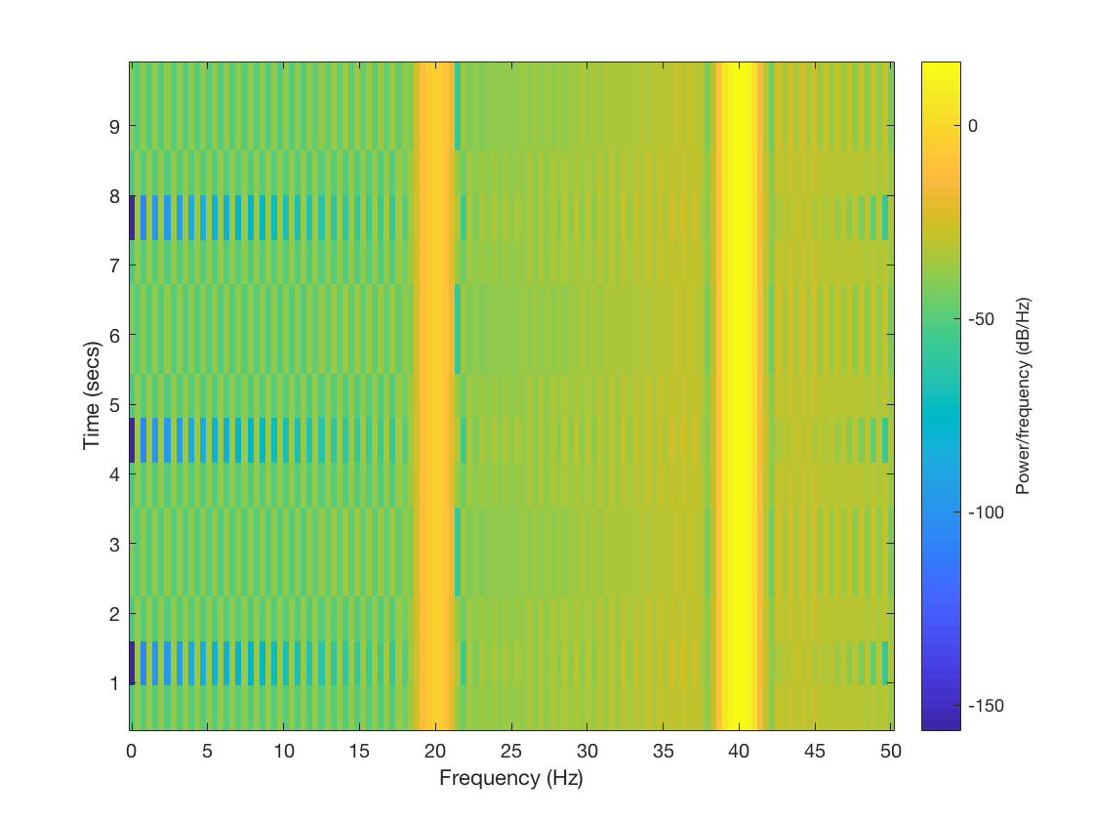

1. I hear a sharp chirping sound, similar to the one’s used in building alarm.
2. I see a different color plot at different sample interval.

fsamp =11025; % set sampling frequency

dt =1/fsamp; % set sampling interval in seconds

dur = 1.5;%set signal duration in seconds

tt=0:dt:dur; % create vector of time samples spaced at dt seconds

psi =2*pi* (500*tt.^2+200*tt +100); % set argument for chirp function

xx=10*cos(psi); % modulate signal with cosine and amplitude cos

soundsc(xx,fsamp);% play signal

specgram(xx,1024,fsamp);% plot spectrogram

This sound is linear chirping sound, and is somewhat similar to the one’s used in building alarm.

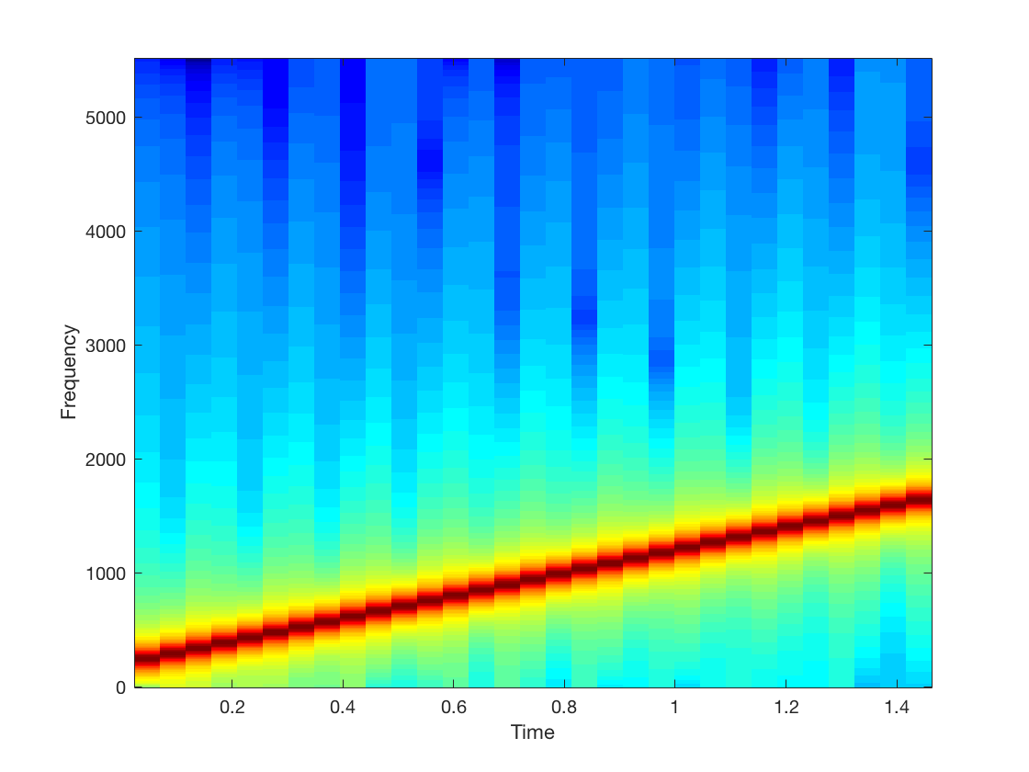

1. From the matlab code, the values are:

t_n =1.5 sec

A= 10

μ=2*pi* (500*tt.^2+200*tt +100);

f_0=200 Hz

φ=100

1. The range in the hertz would be from 0 to 2000 Hz.
2. The signal’s frequency is linearly increasing.

fsamp =11025; % set sampling frequency

dt =1/fsamp; % set sampling interval in seconds

dur = 1.5;%set signal duration in seconds

tt=0:dt:dur; % create vector of time samples spaced at dt seconds

psi =2*pi* (500*tt.^2+200*tt +100); % set argument for chirp function

xx=10*cos(psi); % modulate signal with cosine and amplitude cos

soundsc(xx,fsamp);% play signal

specgram(xx,1024,fsamp);% plot spectrogram

1. function [xx,tt] = mychirp (f1, f2, dur, fsamp )

%MYCHIRP generate a linear-FM chirp signal

xx= mychirp (f1, f2, dur, fsamp )

f1= 400

f2=4000

dur=7

fsamp= 11025

tt=0:7

if (nargin<4)

fsamp = 11025

end

1. function [xx,tt] = mychirp (f1, f2, dur, fsamp )

%MYCHIRP generate a linear-FM chirp signal

xx= mychirp (f1, f2, dur, fsamp )

f1= 5000

f2=500

dur=3

fsamp= 11025

tt=0:3

if (nargin<4)

fsamp = 11025

end

Yes, the frequency movement is linear.

It does chirp down.